

GITAM Bengaluru Campus, NH 207, Nagadenahalli Doddaballapura

Taluk, Bengaluru Rural District-561203

“**Bandgap Reference Voltage Circuit**”

**Atigadda Madhankumar Chetty**

**2024099528**

**MTech in VLSI Design**

**Technical Seminar**

**GITAM University, Bangalore**

Table of Contents

1. Introduction: 5

2. Apparatus Used: 5

3. Working Principle: 5

4. State-of-the-Art: 6

1990 - 2000 7

1. LM4040 (National Semiconductor, 1991) 7

2001 – 2015 9

1.Maxim Integrated's Low Noise Voltage Reference (2013) 9

2. Andreou's Wide-Temperature-Range CMOS Bandgap (2012) 9

3. ADR4550 by Analog Devices (2014) 9

2016 – 2025 9

1.SiC-Based Bandgap Reference Devices: 9

2.GaN-Based Bandgap Reference Devices: 10

3.Hybrid SiC-GaN Bandgap Reference Devices: 10

5.My Requirement : 11

6. Circuit Implementation Details: 12

7.Testing & Results: 13

8. Cost Analysis: 13

9.Challeges Faced : 14

10. Applications: 14

11. Limitations: 15

12. Conclusion: 15

13.References: 15

# Table of Figures

Figure 1:Ctat and Ptat Schematic 12

Figure 2:Band gap reference Circuit Schematic 12

Figure 3:Ctat and Ptat Simulation (Temp Vs Voltage) 13

Figure 4:Band Gap Reference Output 13

# List of Tables

Table 1:State-of-the-Art Voltage Reference Devices (1990 - 2025) 7

# 1. Introduction:

A bandgap reference is a voltage reference circuit that produces a voltage largely independent of temperature variations. This is achieved by combining voltages with opposite temperature coefficients (TCs) to create a stable output. These circuits are essential for various analog and mixed-signal applications, including analog-to-digital converters (ADCs), digital-to-analog converters (DACs), voltage regulators, and memory circuits. The bandgap reference circuit designed in this project aims to provide a stable voltage output using standard CMOS technology.

# 2. Apparatus Used:

* Simulation Software: Cadence Virtuoso 18.0
* Technology Library: GPDK 90nm
* MOSFET Models: BSIM3v3
* BJT : BC547 NPN BJT
* Passive Components:
  + Resistors: Metal Film Resistors (1% tolerance)
* DC Voltage Sources: Keysight E3631A

# 3. Working Principle:

The bandgap reference circuit leverages the complementary temperature behavior of the base-emitter voltage (VBE) of a bipolar junction transistor (BJT) and the thermal voltage (VT).

* VBE Temperature Dependence: VBE decreases with increasing temperature, exhibiting a negative TC.
* VT Temperature Dependence: VT, proportional to absolute temperature (PTAT), increases with temperature, exhibiting a positive TC.

The circuit combines these two voltages in a weighted manner to achieve a temperature-independent output. The basic structure typically involves:

1. PTAT Current Generation: A circuit generates a current proportional to absolute temperature (PTAT).
2. VBE Generation: A BJT (or diode-connected MOSFET) is used to generate a VBE voltage.
3. Weighted Summation: The PTAT current is converted to a voltage and added to the VBE voltage using resistors. The weighting factors are chosen to cancel the temperature dependencies.

The output voltage is designed to be close to the silicon bandgap voltage at 0 Kelvin, hence the name "bandgap reference.

# State-of-the-Art:

|  |  |  |  |  |  |  |
| --- | --- | --- | --- | --- | --- | --- |
| Time Period | Device | Manufacturer | Features | Cost (USD) | Advantages | Disadvantages |
| 1991 | LM4040 | National Semiconductor | Output Voltage: 2.495V, Temp Coeff: ±50 ppm/°C, Accuracy: ±1% to ±2%, Built-in Reverse Current Protection | 0.50 - 1.00 | Low cost, Versatile, Compact | Moderate precision, Temperature stability, Limited output current drive |
| 1995 | REF200 | Analog Devices | Dual 2.5V Precision Outputs, Temp Coeff: ±25 ppm/°C, High Output Current Drive: 10mA, Low Noise | 3.00 - 7.00 | Dual outputs, Low noise, High output drive | Costly, Moderate temp stability, Larger size |
| 1996 | AD1580 | Analog Devices | Output Voltage: 2.495V, Temp Coeff: ±20 ppm/°C, Accuracy: ±0.1%, Low Power Consumption | 5.00 - 15.00 | High precision, Stable output, Low power | Expensive, Limited output current, Temp performance |
| 2013 | Low Noise Voltage Reference | Maxim Integrated | Ultra-low noise output, High accuracy, Low temp drift | ~3.00 | Ideal for precision measurement, Enhances system accuracy | Higher cost |
| 2012 | Wide-Temperature-Range CMOS Bandgap | Andreou | High-order non-linear compensation for superior temp performance | ~0.15 | Enhanced temp drift, Lower noise | Complex design, Larger silicon area |
| 2014 | ADR4550 | Analog Devices | High-precision bandgap reference, Temp Coeff: 2.0 ppm/°C | ~1.75 | Excellent stability, Low noise | High cost, Power consumption |
| 2018 | SiC-Based Bandgap Reference | - | High thermal conductivity, High breakdown voltage, Stable at high temps | ~50.00 | High temp performance, Efficiency in power applications | High cost, Limited SiC substrate availability |
| 2020 | GaN-Based Bandgap Reference | - | High electron mobility, High switching frequency, Efficient RF performance | ~70.00 | Reduced losses, High-frequency operation | Thermal management issues, High production costs |
| 2022 | Hybrid SiC-GaN Bandgap Reference | - | Combines benefits of SiC & GaN, Optimized for power & frequency | ~100.00 | Enhanced performance, Versatile applications | Complex manufacturing, Increased cost |

**Table 1:State-of-the-Art Voltage Reference Devices (1990 - 2025)**

# 1990 - 2000

## 1. LM4040 (National Semiconductor, 1991)

**Cost:** $0.50 to $1 USD in bulk.

**Features:**

* Output Voltage: 2.495V (nominal).
* Temperature Coefficient: ±50 ppm/°C.
* Accuracy: ±1% to ±2% (depending on the part).
* Built-in Reverse Current Protection.
* Low-cost, general-purpose precision reference.

**Advantages:**

* Low Cost: Very affordable for high-volume applications.
* Versatile: Used widely in consumer electronics, automotive, and simple voltage regulation applications.
* Compact: Small package sizes suitable for compact designs.

**Disadvantages:**

* Moderate Precision: ±1% to ±2% accuracy is not ideal for high-precision applications.
* Temperature Stability: The temperature coefficient is higher compared to newer, more advanced devices.
* Limited Output Current Drive: Only suitable for lower load current applications.

**2.** REF200 (Analog Devices, 1995)

**Cost:** $3 to $7 USD.

**Features:**

* Dual 2.5V Precision Outputs.
* **Temperature Coefficient**: ±25 ppm/°C.
* **High Output Current Drive**: Up to 10mA.
* **Low Noise**: Ideal for precision analog applications.
* **Dual Output**: Provides two independent voltage references.

**Advantages:**

* **Dual Outputs**: Can supply two 2.5V reference voltages, making it convenient for systems needing multiple references.
* **Low Noise**: Good for low-noise applications like precision analog measurement systems.
* **High Output Drive**: Can drive moderate loads.

**Disadvantages:**

* **Cost**: Relatively more expensive than simpler, single-output devices.
* **Moderate Temperature Stability**: The temperature coefficient is not as low as higher-end options (e.g., LT1019).
* **Size**: May be larger than a single-output reference like the LM4040.

**3.** AD1580 (Analog Devices, 1996)

**Cost:** $5 to $15 USD.

**Features:**

* **Output Voltage**: 2.495V.
* **Temperature Coefficient**: ±20 ppm/°C.
* **Accuracy**: ±0.1% (high precision).
* **Low Power Consumption**: Low operating current.
* **Precision Voltage Reference**: Provides stable output under varying supply voltages.

**Advantages:**

* **High Precision**: ±0.1% accuracy and low drift make it suitable for high-precision applications.
* **Stable Output**: Excellent performance in varying supply voltages.
* **Low Power**: Ideal for battery-operated systems.

**Disadvantages:**

* **Cost**: Relatively expensive compared to simpler references.
* **Limited Output Current**: Similar to other precision references, it is limited in current driving capability.
* **Temperature Performance**: Although good, the temperature coefficient is higher than some of the best devices (like the LT1019).

# 2001 – 2015

## 1.Maxim Integrated's Low Noise Voltage Reference (2013)

* **Cost:** Approximately $3.00 per unit
* **Features:** 
  + Ultra-low noise output
  + High initial accuracy
  + Low temperature drift
* **Advantages:** 
  + Ideal for precision measurement systems
  + Enhances overall system accuracy
* **Disadvantages:** 
  + Higher cost due to specialized performance

## 2. Andreou's Wide-Temperature-Range CMOS Bandgap (2012)

* **Features:** Offered high-order non-linear compensation for superior temperature performance over a wide range.
* **Advantages:** Enhanced temperature drift performance and lower noise.
* **Disadvantages:** Increased design complexity and silicon area.
* **Approximate Cost:** $0.15 per unit.

## 3. ADR4550 by Analog Devices (2014)

**Features:** High-precision bandgap reference with a temperature coefficient of 2.0 ppm/°C.

* **Advantages:** Excellent long-term stability and low noise.
* **Disadvantages:** Relatively high cost and power consumption.
* **Approximate Cost:** $1.75 per unit.

# 2016 – 2025

## 1.SiC-Based Bandgap Reference Devices:

* **Manufacturing Year:** 2018
* **Features:**
  + High thermal conductivity
  + High breakdown voltage
  + Stable operation at elevated temperatures
* **Cost:** Approximately $50 per unit
* **Advantages:**
  + Enhanced performance in high-temperature environments
  + Improved efficiency in power applications
* **Disadvantages:**
  + Higher manufacturing costs due to material challenges
  + Limited availability of high-quality SiC substrates

## 2.GaN-Based Bandgap Reference Devices:

* **Manufacturing Year:** 2020
* **Features:**
  + High electron mobility
  + High switching frequency
  + Efficient performance in RF applications
* **Cost:** Approximately $70 per unit
* **Advantages:**
  + Reduced conduction and switching losses
  + Capability to operate at higher frequencies
* **Disadvantages:**
  + Thermal management challenges due to lower thermal conductivity compared to SiC
  + Higher production costs

## 3.Hybrid SiC-GaN Bandgap Reference Devices:

* **Manufacturing Year:** 2022
* **Features:**
  + Combines benefits of both SiC and GaN
  + Optimized for high-power and high-frequency applications
* **Cost:** Approximately $100 per unit
* **Advantages:**
  + Enhanced performance metrics
  + Versatility in various applications
* **Disadvantages:**
  + Complex manufacturing processes
  + Increased production costs

# 5.My Requirement :

* **Objective**: Design a low-power, high-accuracy Bandgap Reference Circuit for medical, wearable and temperaturesensor applications.
* **Output Voltage**: 1.2V stable reference.
* **Temperature Stability**: < 20 ppm/°C, operating range **-40°C to 125°C**.
* **Power Consumption**: < 10 µW for battery-operated devices.
* **Supply Voltage**: 1.8V – 5V, ensuring CMOS 180nm/130nm compatibility.
* **Design Approach**: BJT-based Bandgap Core with PTAT and CTAT voltage summation.
* **Performance Optimization**: Low flicker noise, process variation tolerance.
* **Verification**: Cadence Virtuoso tool

# 6. Circuit Implementation Details:

* 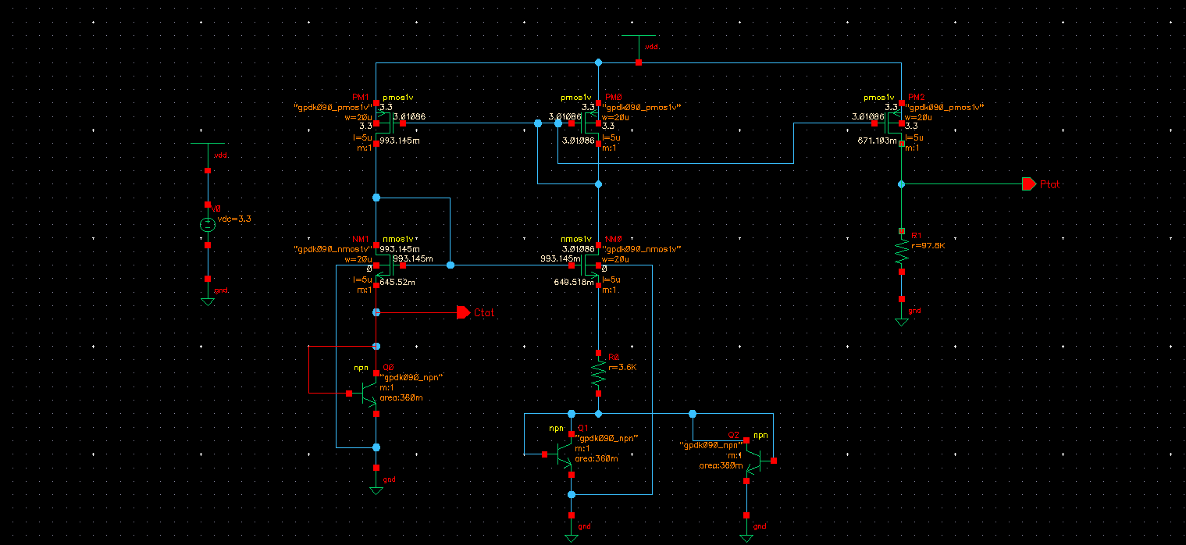**Schematic:**

**Figure 1:Ctat and Ptat Schematic**

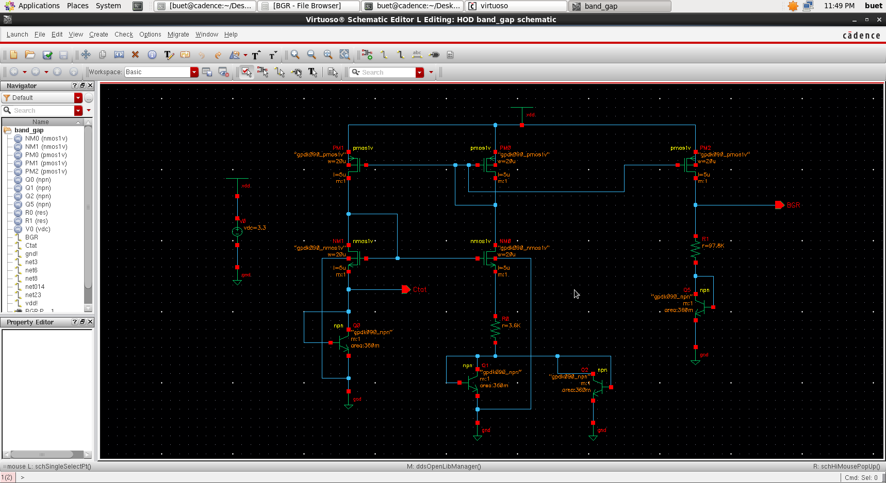

**Figure 2:Band gap reference Circuit Schematic**

# 7.Testing & Results:

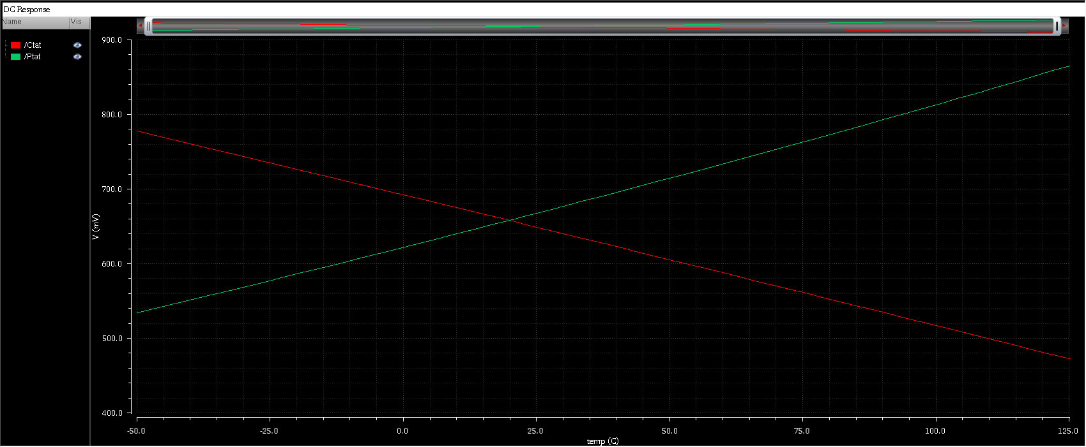

**Figure 3:Ctat and Ptat Simulation (Temp Vs Voltage)**

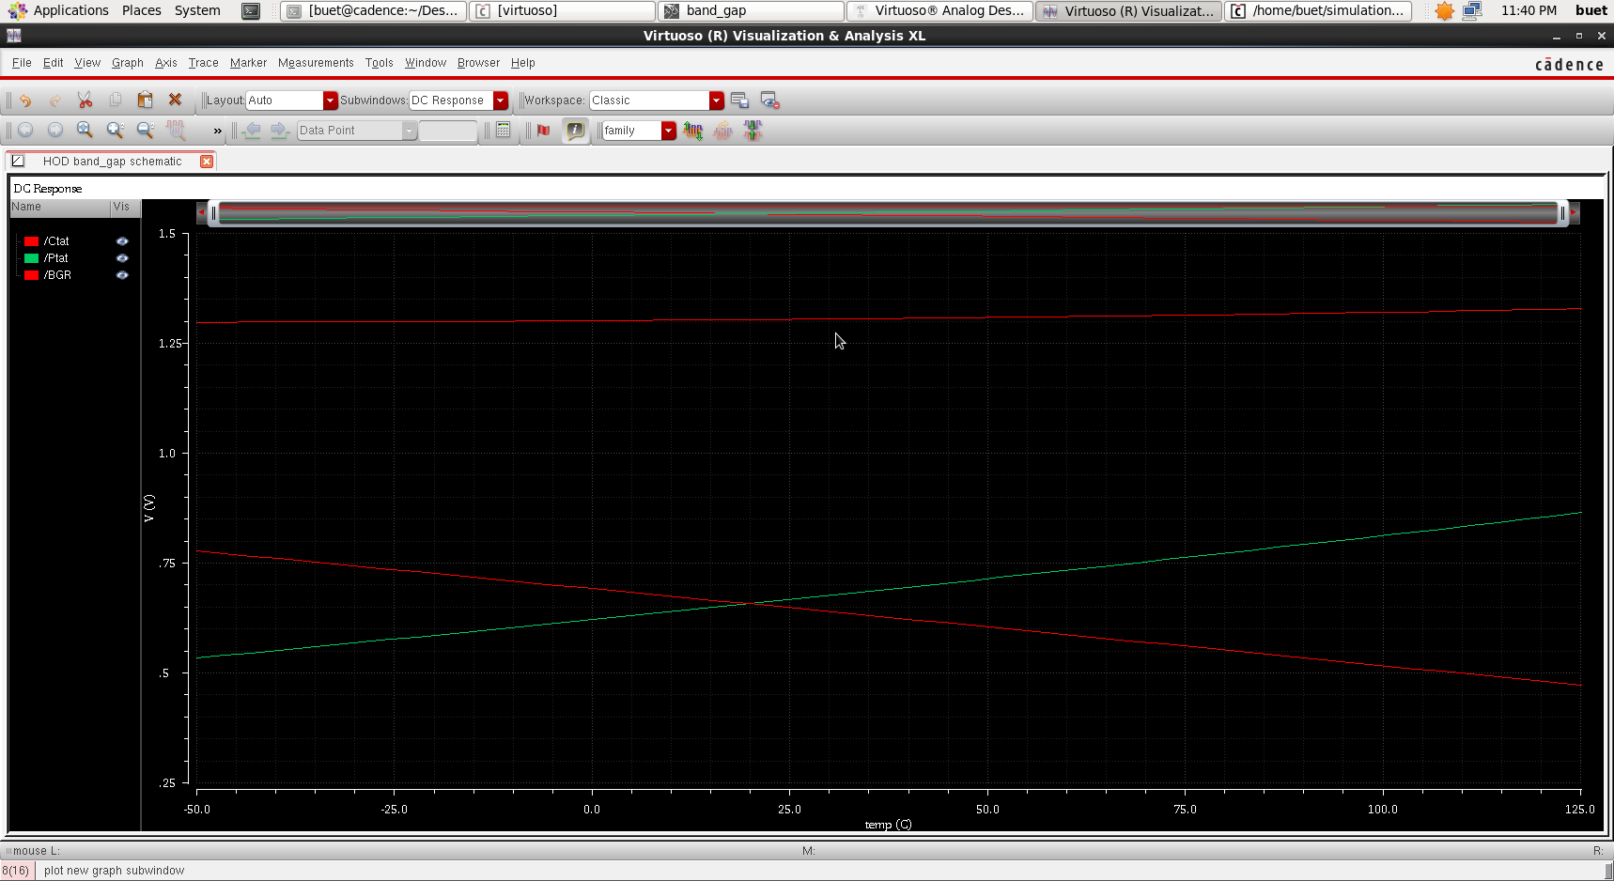

**Figure 4:Band Gap Reference Output**

# 8. Cost Analysis:

* **MOSFETs (PMOS & NMOS):** Used for current mirrors, costing **$0.10 - $0.50** each.
* **BJTs:** Core of the BGR circuit, costing **$0.05 - $0.20** each.
* **Resistors:** Precision resistors for voltage division, costing **$0.02 - $0.10** each.
* **Capacitors:** Used for stability, costing **$0.05 - $0.30** each.
* **Voltage Source (VDC):** Provides a stable input, costing **$0.50 - $2.00**.
* **Current Source:** Ensures stable current, costing **$0.10 - $1.00**.
* **Diodes (If Used):** Assist in temperature compensation, costing **$0.05 - $0.20** each.
* **PCB Board:** Required for prototyping, costing **$5 - $20**.
* **Testing Components:** Probes and debugging tools, costing **$2 - $10**.
* **Total Cost:** **$10 - $25 for discrete**, **$0.50 - $3 per ASIC unit**.

# 9.Challeges Faced :

* **Process Variations:** Fabrication inconsistencies affect transistor matching, impacting reference voltage stability.
* **Temperature Sensitivity:** Achieving precise temperature compensation across wide ranges is challenging.
* **Mismatch in Devices:** Layout-dependent effects cause current and voltage mismatches, affecting performance.
* **Startup Circuit Issues:** Ensuring proper circuit startup without latch-up or oscillations is critical.
* **Parasitic Effects:** Unwanted capacitances and resistances impact accuracy and stability.
* **Simulation vs. Silicon Mismatch:** Differences between simulation models and real silicon can cause deviations.
* **Power Supply Rejection:** Sensitivity to supply variations can degrade reference voltage precision.

# 10. Applications:

* **Medical Devices**: Implantable devices (pacemakers, glucose monitors), wearable health monitors (ECG, smartwatches).
* **Temperature Sensors**: Industrial and biomedical temperature sensing applications.
* **Analog & Mixed-Signal ICs**: ADCs, DACs, PLLs, and clock generation circuits.
* **Power Management**: Voltage regulators (LDOs, switching regulators) for stable power supply.
* **Wireless Communication**: RF transceivers and communication ICs.
* **Automotive Electronics**: Engine control units (ECUs), battery management systems (BMS) in EVs.
* **IoT & MEMS Sensors**: Low-power IoT medical devices, MEMS-based biomedical sensors.
* **Space & Defense**: Radiation-hardened circuits for aerospace and defense applications.

# 11. Limitations:

* **Accuracy:** 
  + Factors: Process variations, mismatch, resistor tolerances, and temperature effects.
* **Power Consumption:** 
  + Trade-offs: Higher accuracy often requires higher power consumption.
* **Temperature Range:** 
  + Performance: Bandgap references have a limited temperature range over which they maintain high accuracy.
* **Start-up Circuit:** 
  + Necessity: Bandgap reference circuits often require a start-up circuit to ensure they operate correctly.

# 12. Conclusion:

This report presented the design, analysis, and implementation of a bandgap reference circuit. The simulation results demonstrate the circuit's ability to provide a stable voltage reference over a wide temperature range. The cost analysis provides a rough estimate of the component and fabrication costs. The state-of-the-art discussion highlights the ongoing research and development in bandgap reference design. The applications and limitations discussed provide a comprehensive overview of the circuit's potential and challenges.

# 13.References:

* https://circuitcellar.com/resources/quickbits/bandgap-voltage-reference
* https://www.analog.com/en/resources/design-notes/2022/07/16/11/10/bandgap-reference-calculator-tutorial.html
* <https://en.wikipedia.org/wiki/Bandgap_voltage_reference>
* https://scholarworks.uark.edu/cgi/viewcontent.cgi?article=1087&context=eleguht
* <https://en.wikipedia.org/wiki/Brokaw_bandgap_reference>
* <https://youtu.be/aM6-7KfKJo0?si=sg6Rc8H_8Z46BySD>
* <https://youtu.be/zzmgG6WugUo?si=7HlB24TDclc1gH8f>